|  |  |  |
| --- | --- | --- |
| Member 1 | Nabh Sanjay Mehta | NSM190002 |
| Member 2 | Anil Kumar Yadav Kare | Axk190056 |
| Class | BUAN 6312.003 | Thursday 4-7PM batch |

Q 1.1:

Part a:

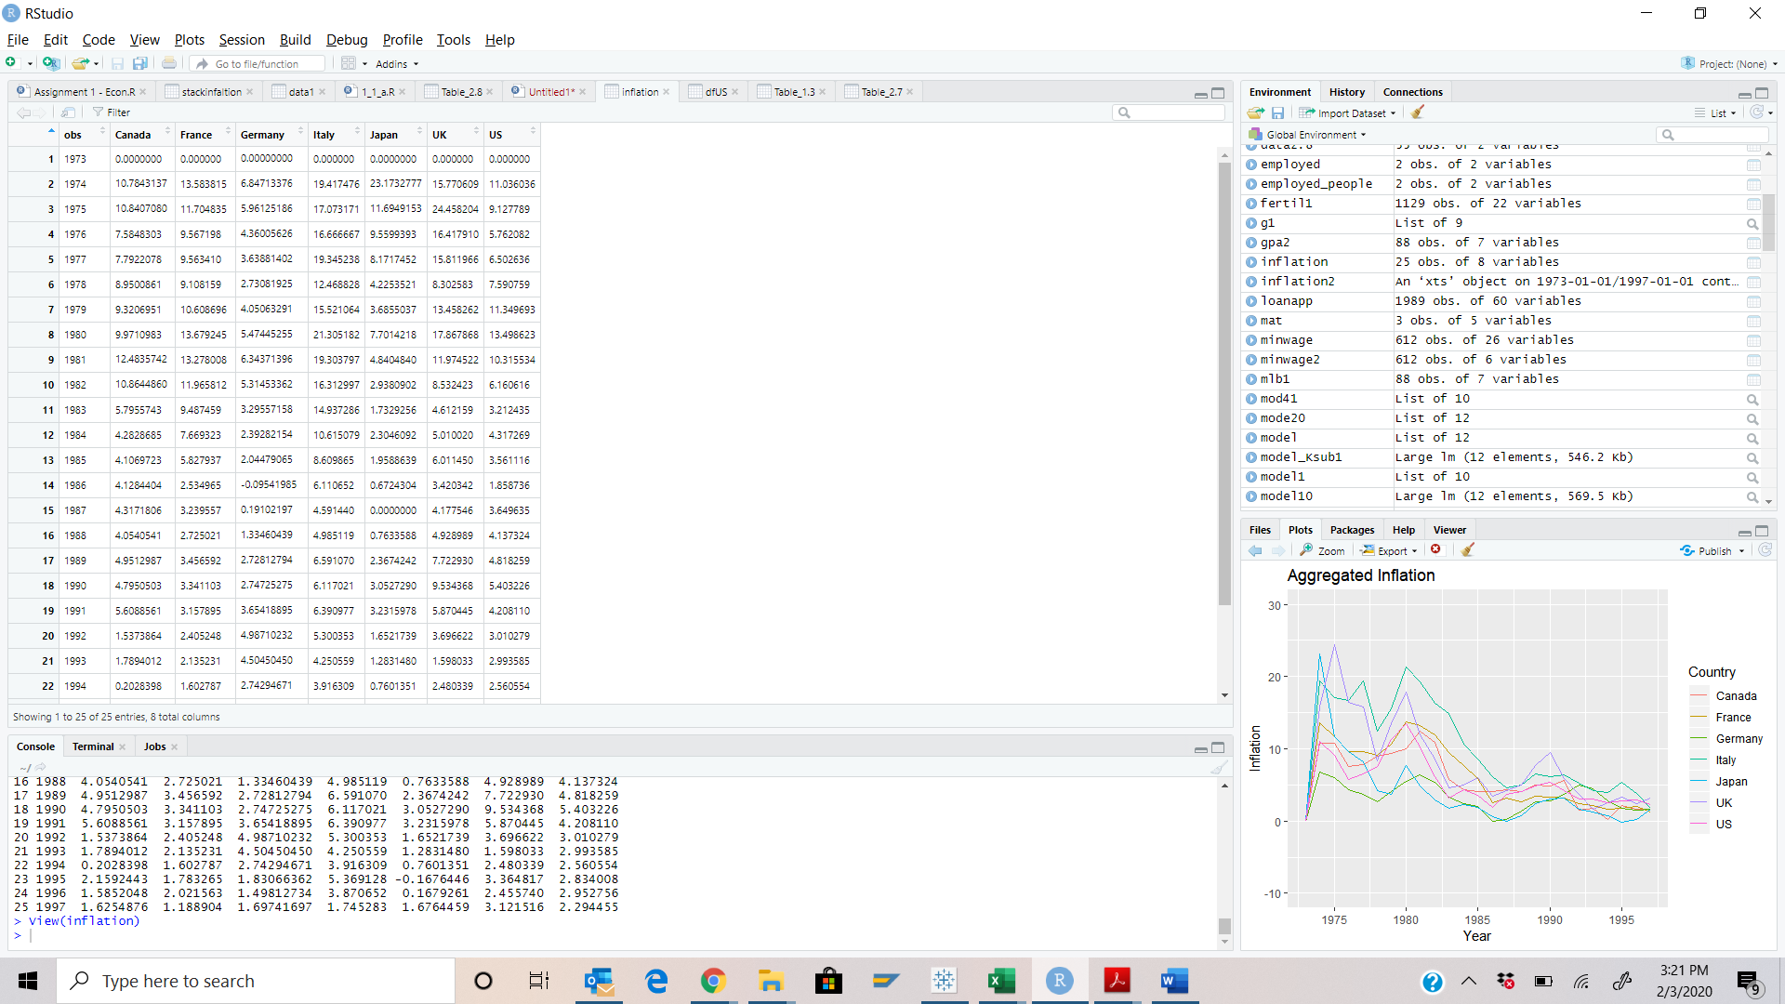

Part b:

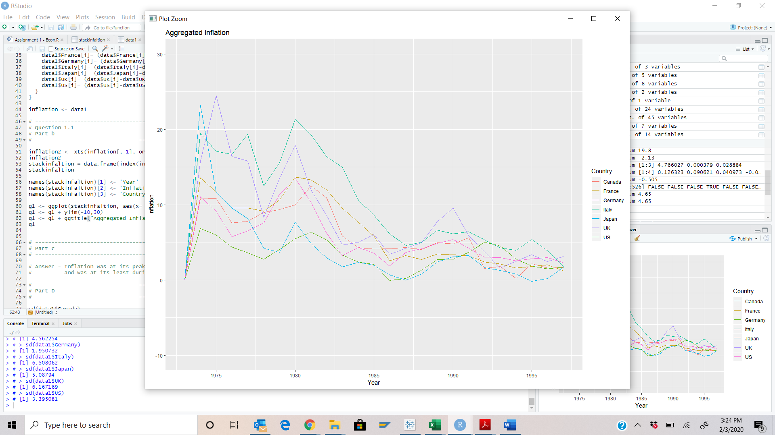

Part c: Inflation was at its peak for all countries during year 1975, however it gradually declined over the period and was at its least during Year 1995

Part d: We used standard deviation to identify variability in inflation and found that Italy had maximum whereas Germany had the least.

Q 1.2

Part a:

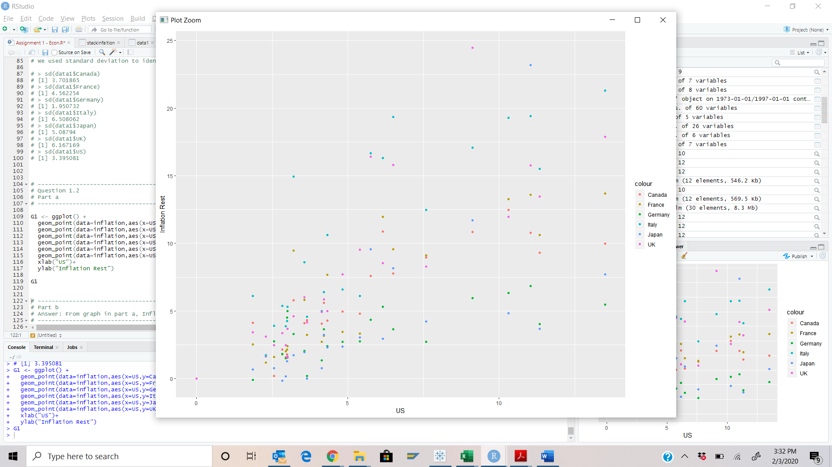

Part b: From graph in part a, Inflation of other countries appear to have a positive correlation with Inflation of the US

Part c: A statistical relationship, however strong and however suggestive, can never establish causal connection. Our ideas of causation must come from outside statistics, ultimately from some other theory etc.

Q 1.3

Part a:

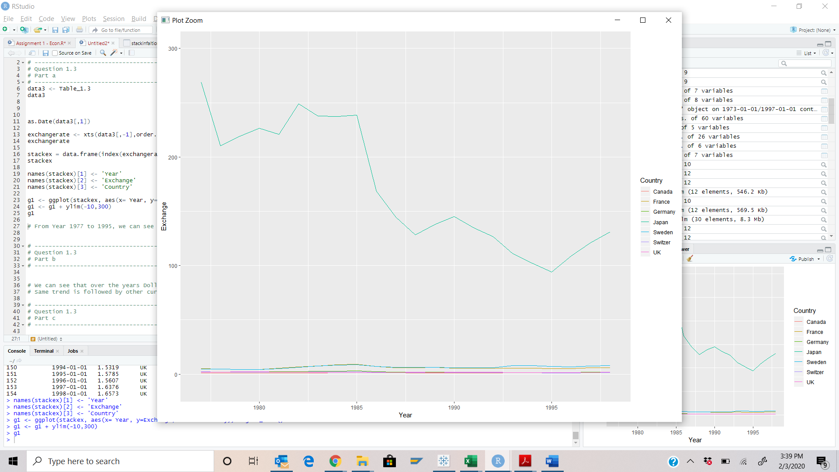

# From Year 1977 to 1995, we can see drastic dip or variability in Japanese currency Yen.

Part b: We can see that over the years Dollar is able to fetch lesser number of Yen units and the variability is high. Same trend is followed by other currencies too.